**Assignment – 2**

**Question -1**

**• Connect to the Store Sales Data and do the following: -**

**− Remove all the blank rows.**

**− Update the column header if they are not updated**

**− Create a text table and show the sales in terms of**

**o Customers**

**o Product Category**

**o Regions**

**Answer:**

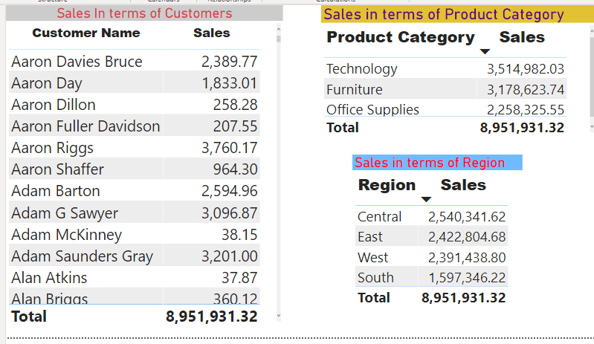

**Question -2**

**Create a line and Clustered Column Chart showing the Sales and Discount as per the State or Province**

**− Format the bars and line with different colors**

**− Which state has the highest sales in terms Technology**

**Answer:** New York has highest sales in terms of Technology

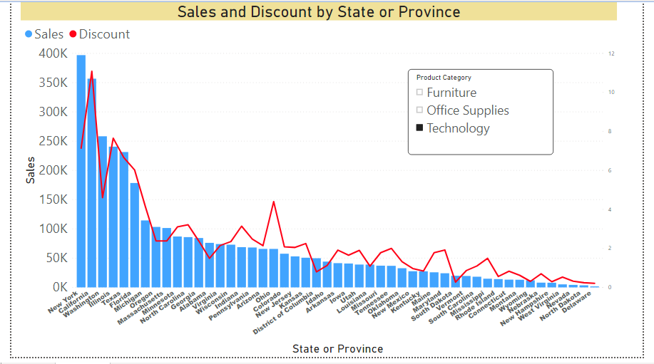

**Question -3**

**• Create a Donut Chart showing sales in terms of Product category**

**Answer:**

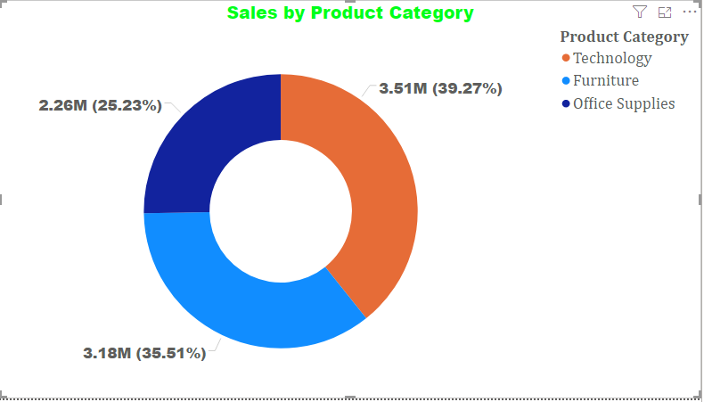

**Question -4**

**• Create a Slicer and show the regions in dropdown. See how all the visuals mentioned above behaving when a particular region is selected.**

**Answer:**

**When South region is selected**

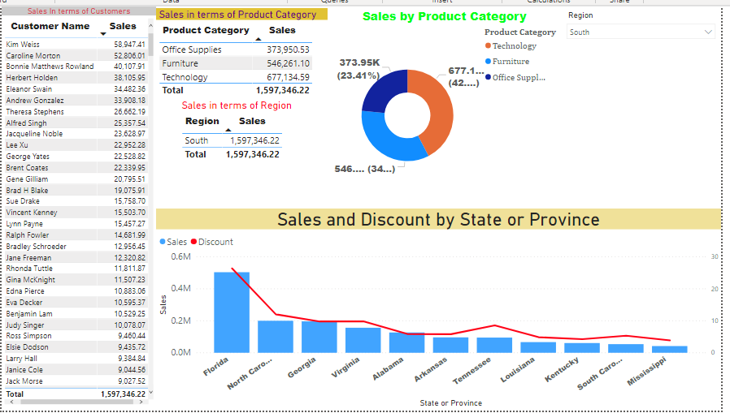

**When East region is selected**

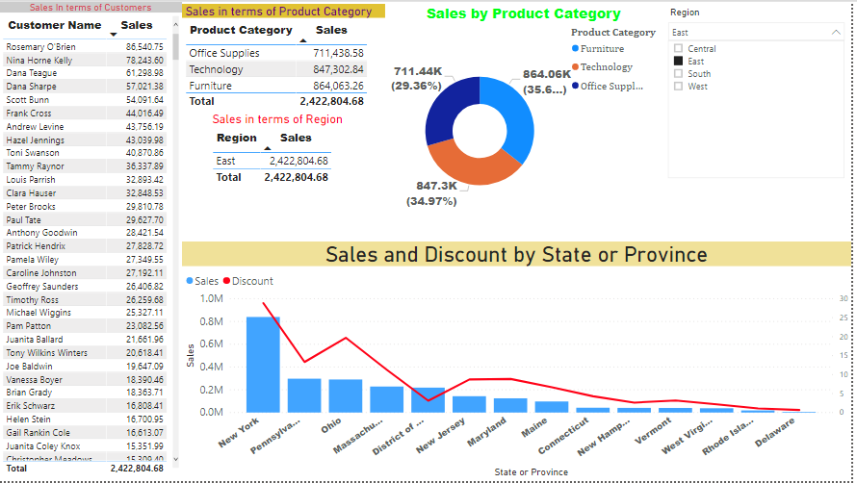

**When All regions are selected**

